Work 2. Optimal control design with fixed endpoints

Problem statement
Plant, cost and boundary conditions of variant 5:
${\overset{˙}{x}}_{1}=x_{2},{\overset{˙}{x}}_{2}=−6x_{1}−5x_{2}+u$
$J=\int_{0}^{4}{(x_{1}^{2}+4x_{2}^{2}+5u^{2})dt}$
$x(0)=0,x_{1}(4)=1,x_{2}(4)=0$

Synthesis (Pontryagin minimum principle)
The Hamiltonian gives the optimal control and the costate equations; the resulting two-point boundary-value problem is solved numerically.
$H=x^{T}Qx+ru^{2}+λ^{T}(Ax+bu)$
$u^{*}=−\frac{b^{T}λ}{2r}=−\frac{λ_{2}}{10}$
$\overset{˙}{λ}=−2Qx−A^{T}λ$
BVP converged: True
x(4) = [1.0, 1.306389502462148e-18] (target [1, 0])
optimal cost J = 302.9033
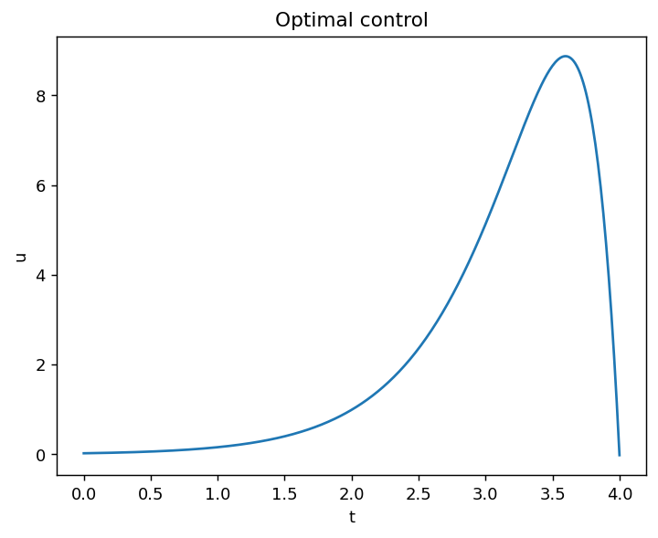
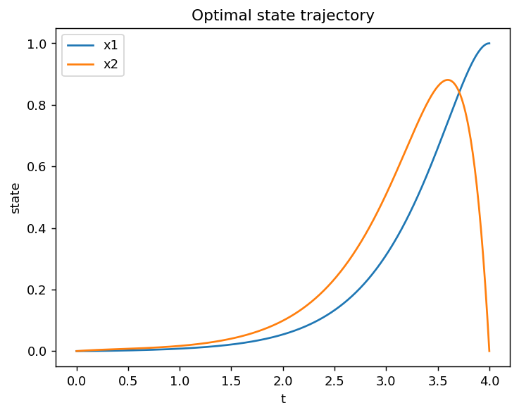
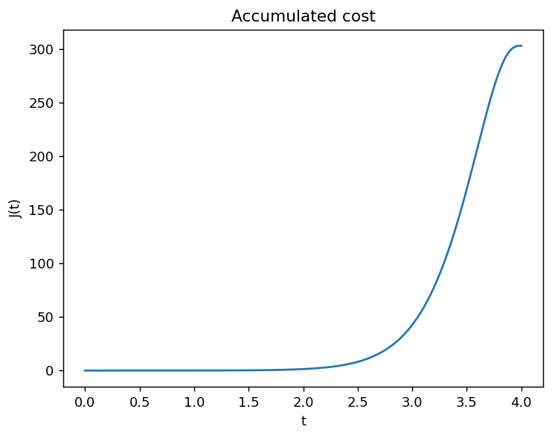

Cost for changed controller parameters
The open-loop controller is re-designed with a different control-weight r. Every re-designed control still satisfies the boundary conditions, but evaluated under the nominal cost functional the minimum is reached exactly at the optimal design r = 5, which confirms optimality.
best r = 5.0000
